Smart Healthcare Appointment and Resource Management System



Project Sponsor
Prof. David Pitts, Rivier University

Submitted by
Sravan Kumar Reddy Pergu _ 0104363
Spring-2026 _ RIVIER UNIVERSITY

USECASE DIAGRAM

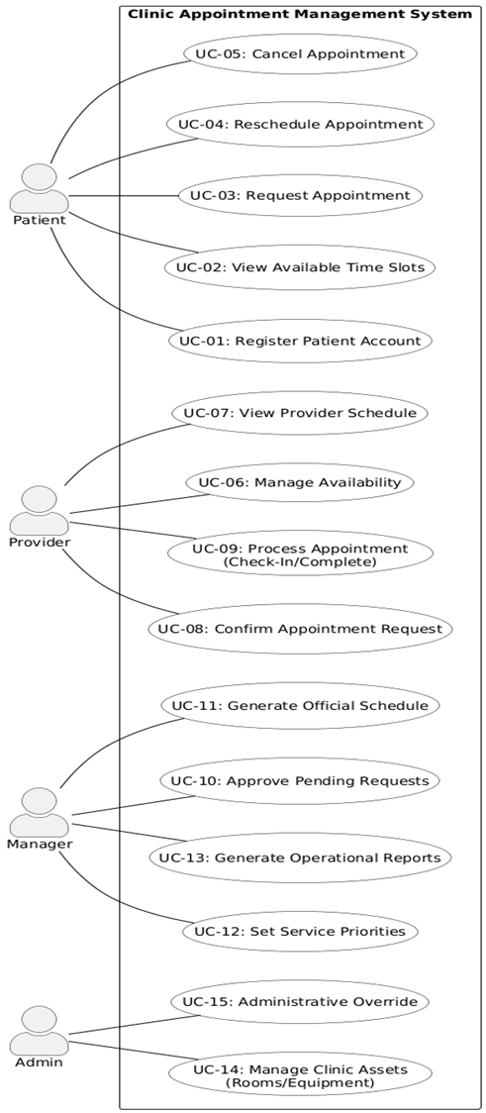

CLASS DIAGRAM
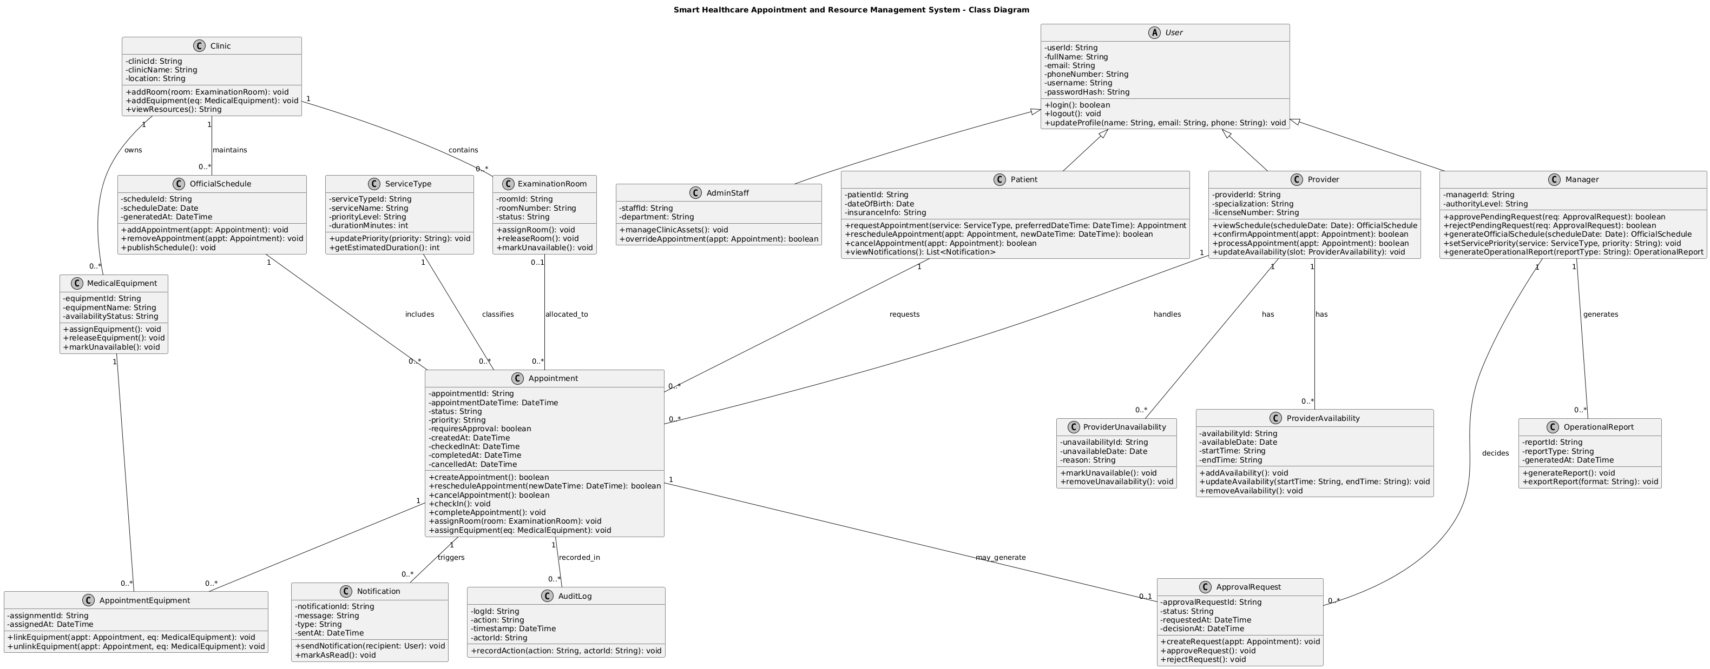

OBJECT DIAGRAM
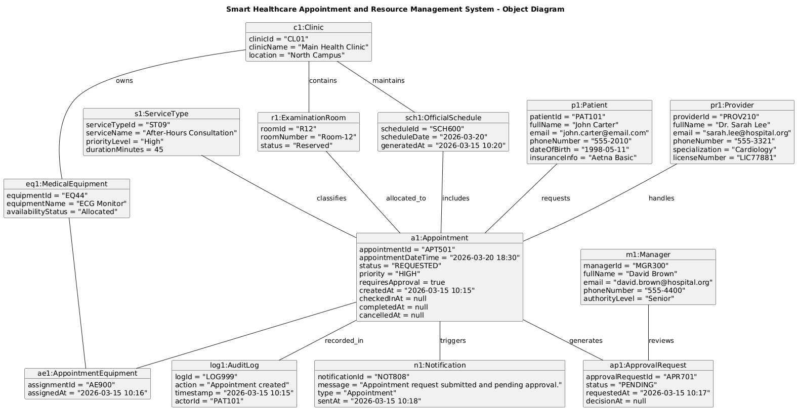

SEQUENCE DIAGRAMS

- REQUEST APPOINTMENT
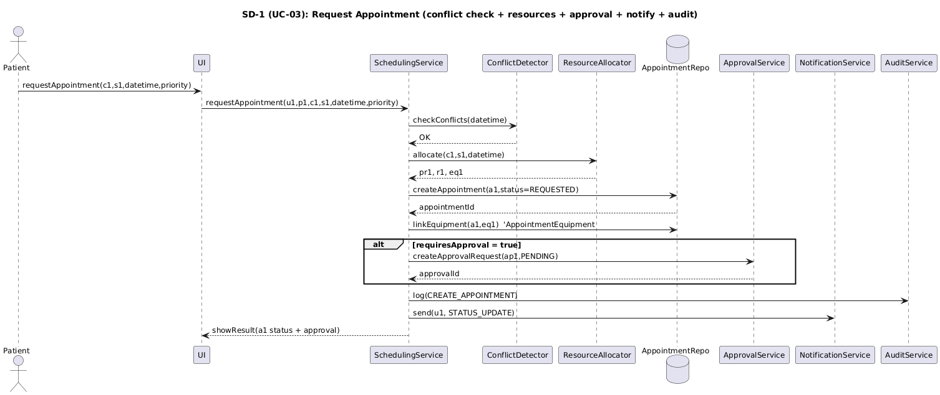

- APPROVE PENDING REQUESTS
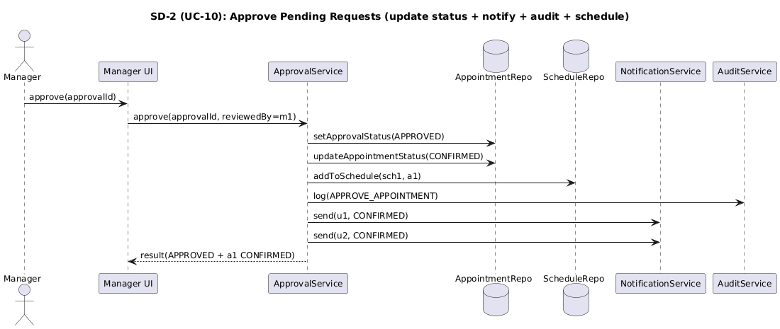

Derivation of Structural and Behavioral Models

1. Derivation of the Structural Model (Class Diagram)
The class diagram was derived directly from the functional use cases.
The nouns identified in the use case descriptions were converted into domain classes.
- The actors Patient, Provider, Admin Staff, and Manager were modeled as subclasses of the abstract class User to support role-based access control.
- The use case UC-03 Request Appointment led to the creation of the Appointment class with attributes such as status, priority, requiresApproval, createdAt, checkedInAt, completedAt, and cancelledAt to represent the appointment lifecycle.
- The requirement to prevent double booking resulted in the inclusion of ProviderAvailability and Provider Unavailability classes.
- The need to manage clinic assets (UC-14) resulted in the classes Clinic, ExaminationRoom, and MedicalEquipment.
- Because appointments may require medical equipment, a many-to-many relationship between Appointment and MedicalEquipment was implemented through the association class AppointmentEquipment.
- The use case UC-10 Approve Pending Requests resulted in the creation of the ApprovalRequest class linked to Appointment and Manager.
- The requirement to log actions resulted in the inclusion of the AuditLog class.
- The requirement to notify users resulted in the Notification class.
- The use case UC-11 Generate Official Schedule resulted in the OfficialSchedule class.
- The use case UC-13 Generate Operational Reports resulted in the OperationalReport class.
The structural model was refined iteratively to ensure that all use cases were supported by appropriate classes and relationships.

2. Derivation of the Object Diagram
The object diagram was created using a specific scenario from UC-03 Request Appointment where a high-priority after-hours appointment requires managerial approval.
The object diagram demonstrates:
- An instance of Appointment (a1) in REQUESTED state.
- An instance of ApprovalRequest (ap1) in PENDING state.
- Allocation of a specific ExaminationRoom (r1).
- Association with specific MedicalEquipment (eq1).
- A generated Notification (n1).
- An AuditLog (log1) entry recording appointment creation.
- An OfficialSchedule (sch1) instance that groups appointments by date and clinic.
This diagram validates that the structural relationships defined in the class diagram work correctly in a real-world scenario.
3. Derivation of the Behavioral Model (Sequence Diagrams)
The sequence diagrams were developed directly from the main flow steps in the use case descriptions.
For UC-03 Request Appointment, the sequence diagram models:
- User authentication.
- Conflict detection to prevent double booking.
- Resource allocation (provider, room, equipment).
- Appointment creation.
- Approval request generation (if required).
- Audit logging.
- Notification sending.
For UC-10 Approve Pending Requests, the sequence diagram models:
- Manager authentication.
- Retrieval of pending approval requests.
- Approval decision.
- Update of appointment status.
- Addition to official schedule.
- Notification to patient and provider.
- Audit logging.
Each message in the sequence diagrams corresponds to responsibilities defined in the class diagram, ensuring traceability between the functional, structural, and behavioral models.

Traceability Between Models

The use case diagram defines the functional requirements of the system, while the structural and behavioral models were derived directly from those use cases.
Each use case is traceable to specific structural components and corresponding behavioral sequences:
- UC-03 Request Appointment is supported by the classes Appointment, ServiceType, ProviderAvailability, ExaminationRoom, MedicalEquipment, AppointmentEquipment, ApprovalRequest, Notification, and AuditLog. Its dynamic behavior is modeled in the Request Appointment Sequence Diagram.
- UC-10 Approve Pending Requests is supported by the classes ApprovalRequest, Manager, Appointment, OfficialSchedule, and Notification. Its interaction flow is modeled in the Approve Pending Requests Sequence Diagram.
- UC-14 Manage Clinic Assets is supported structurally by Clinic, ExaminationRoom, and MedicalEquipment.
- UC-11 Generate Official Schedule is supported by the OfficialSchedule class and its relationship to Appointment.
- UC-13 Generate Operational Reports is supported by the OperationalReport class.
The object diagram demonstrates a concrete instance of UC-03, showing an Appointment in REQUESTED state with a linked ApprovalRequest in PENDING state, allocated room and equipment, audit logging, and notification generation.
Thus, every use case is explicitly supported by at least one structural element in the class diagram and one behavioral representation in the sequence diagrams, ensuring full traceability between functional, structural, and behavioral models.

Class-to-Use-Case Traceability Table
CLASS | USE CASE NO(s) | USE CASE NAMES
User | UC-01, UC-03, UC-06, UC-10, UC-15 | Register Patient Account; Request Appointment; Manage Availability; Approve Pending Requests; Administrative Override
Patient | UC-01, UC-03, UC-04, UC-05 | Register Patient Account; Request Appointment  Reschedule Appointment; Cancel Appointment
Provider | UC-02, UC-03, UC-06, UC-07, UC-08, UC-09 | View Available Time Slots; Request Appointment; Manage Availability; View Provider Schedule; Confirm Appointment Request; Process Appointment
AdminStaff | UC-14, UC-15 | Manage Clinic Assets; Administrative Override
Manager | UC-10, UC-11, UC-12, UC-13 | Approve Pending Requests; Generate Official Schedule; Set Service Priorities; Generate Operational Reports
Clinic | UC-02, UC-03, UC-11, UC-14 | View Available Time Slots; Request Appointment; Generate Official Schedule; Manage Clinic Assets
ServiceType | UC-02, UC-03, UC-12 | View Available Time Slots; Request Appointment; Set Service Priorities
ExaminationRoom | UC-03, UC-14 | Request Appointment; Manage Clinic Assets
MedicalEquipment | UC-03, UC-14 | Request Appointment; Manage Clinic Assets
ProviderAvailability | UC-02, UC-06 | View Available Time Slots; Manage Availability
ProviderUnavailability | UC-06 | Manage Availability
Appointment | UC-03, UC-04, UC-05, UC-07, UC-08, UC-09, UC-10, UC-11 | Request Appointment; Reschedule Appointment; Cancel Appointment; View Provider Schedule; Confirm Appointment Request; Process Appointment; Approve Pending Requests; Generate Official Schedule
AppointmentEquipment | UC-03 | Request Appointment
ApprovalRequest | UC-03, UC-10, UC-15 | Request Appointment; Approve Pending Requests; Administrative Override
Notification | UC-03, UC-04, UC-05, UC-10 | Request Appointment; Reschedule Appointment; Cancel Appointment; Approve Pending Requests
AuditLog | UC-03, UC-04, UC-05, UC-06, UC-10, UC-14, UC-15 | Request Appointment; Reschedule Appointment; Cancel Appointment; Manage Availability; Approve Pending Requests; Manage Clinic Assets; Administrative Override
OfficialSchedule | UC-10, UC-11 | Approve Pending Requests; Generate Official Schedule
OperationalReport | UC-13 | Generate Operational Reports

